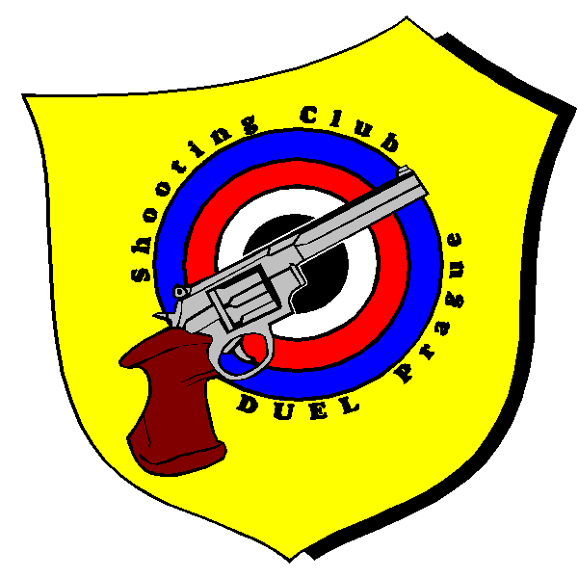
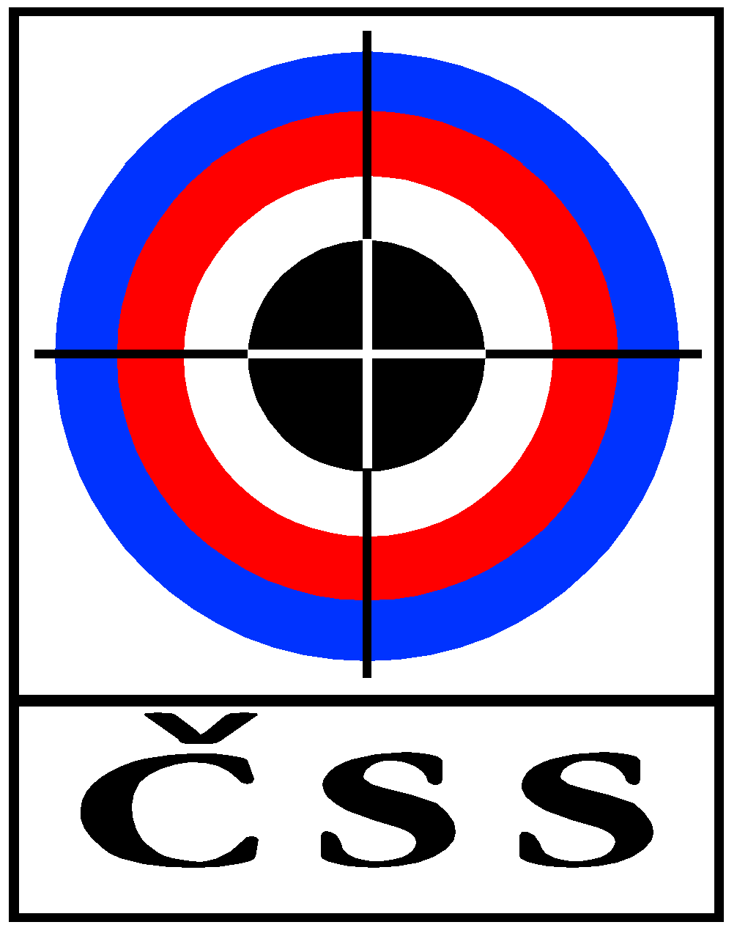

Date: 7. 12. and 8. 12. 2024
City: Pilsen – Lobzy / CZE

Events: Air Pistol 60, Air Pistol 40, Air Gewehr 60, Air Gewehr 40
Division: 1) Men and Juniormen (AP/AR 60)
2) Women and Juniorwomen (AP/AR 60)
3) Juniormen – in 18 age (AP/AR 40)
4) Juniorwomen – in 18 age (AP/AR 40)
Programme 7. 12. 2024:
08:00 - Prezentation in nach Shift (min. one hour ahead of Shift)
09:00 - 10:35 1. Relay AG 60 (Men, Juniormen)
10:50 - 12:25 2. Relay AG 60 (Men) AP 60 (Juniormen)
12:40 - 14:15 3. Relay AP 60 (Men, Juniormen)
14:30 - 16:05 4. Relay AP 60, AG 60 (Women and Juniorwomen)
16:20 - 17:30 5. Relay AP 40, AG 40 (Juniormen and Juniorwomen – in 18 age)
17:45 - 18:55 6. Relay AP 40, AG 40 (Juniormen and Juniorwomen – in 18 age)

Saturday: Finale AP 60 and Finale AR 60
Programme 8. 12. 2024:
08:00 - Prezentation in nach Shift (min. one hour ahead of Shift)
09:00 - 10:35 1. Shift alles
10:55 - 12:30 2. Shift alles
12:50 - 14:25 3. Shift alles
14:45 - 16:20 4. Shift alles
in Sunday finale there're not

Starting: 300,- CZK (13,- Euro) under competitor and start

Anwendungen hier - Bitte senden Sie es bis zum 24. November per E-Mail (streit@sskduel.cz)
Jiri Streit, Wettbewerbsleiter

